Supplementary Materials:
Reliability Conditions for Interpreting Daily NASA Black Marble Nighttime Lights in Cloud-Impacted Tropical Regions
Authors: Rene Jr. L. Principe, Karin Reinke, and Simon Jones
This document provides supporting figures, tables, and diagnostic analyses that complement the main manuscript. It expands key results by presenting full-resolution metrics, illustrative examples, and methodological details that reinforce the reliability framework.
Table of Contents
- Points of Interest and Spatial Supports
- Anatomy of NTL Observability and Gap-Filling Effects
- Long-Term Structure of Spatial Completeness
- Pre–Post Event Radiance Differences Across Spatial Supports
- Kernel-Scale Comparison of DNB-BRDF and Gap-Filled Radiance
- Full POI-Level Observability Metrics
- Settlement-Scale Observability Summary
- Example GHSL Thematic Masks
- Effect of Spatial Completeness Threshold on Event Signal Structure
- Effect of Spatial Completeness Threshold on NTL–Load Signal Structure
- Top Five Reliability-Qualified Alignment Configurations
- Supplementary References
I. Points of Interest and Spatial Supports
To complement settlement-scale diagnostics, ten representative points-of-interest (POIs) were defined across Samar–Leyte to characterise local-scale observability under varying settlement intensity and land-cover conditions. These POIs provide controlled reference locations for examining radiance behaviour at fine spatial scales, independent of thematic aggregation.
The selected sites span three settlement contexts. Urban POIs include Tacloban City Centre, Ormoc City Centre, and Baybay City Centre, representing high-density electrified environments. Municipal and peri-urban POIs include Palo, Alang-Alang, and Guiuan, capturing intermediate radiance levels and heterogeneous infrastructure. Non-settlement reference sites include Samar Forest Reserve, Mt. Nacolod Upland, Central Leyte Forest, and Southern Leyte Gulf, representing minimally illuminated or uninhabited conditions.
All POIs were aligned to the native 500 m VIIRS grid to ensure pixel-consistent extraction from the NASA Black Marble VNP46A2 product (Román et al., 2018). Radiance was summarised using three nested spatial supports: 1×1 (single pixel), 3×3 (9 pixels), and 5×5 (25 pixels). This nested design isolates the effect of spatial aggregation on signal stability. The 1×1 support preserves strict locality but is highly sensitive to cloud masking and transient variability. Larger supports increase spatial support and reduce local radiance variability through averaging, but do not consistently increase completeness.
These POI-based diagnostics are used exclusively to examine fine-scale observability and kernel effects; settlement-level ranking and alignment are performed using GHSL-stratified aggregation in the main manuscript.
Table S1. Points of interest (POIs) used for pixel- and patch-level observability diagnostics.
Group | POI name | Coordinates | Rationale
City Centres | Tacloban City Centre | [125.0015, 11.2434] | Regional capital; severely affected by Haiyan; dense urban lighting
City Centres | Ormoc City Centre | [124.6068, 11.0088] | West Leyte urban hub; port; stable electrification
City Centres | Baybay City Centre | [124.7989, 10.6766] | Smaller coastal city; consistent urban lights
Municipal Centres | Palo | [124.9904, 11.1577] | Suburban east of Tacloban; major resettlement areas
Municipal Centres | Alang-Alang | [124.8465, 11.2071] | Inland peri-urban near Tacloban
Municipal Centres | Guiuan | [125.7232, 11.0312] | Southern Samar town; near Haiyan landfall
Non-settlement Areas | Samar Forest Reserve | [125.1870, 11.7740] | Remote forest; negligible light
Non-settlement Areas | Mt. Nacolod Upland | [125.3100, 11.4960] | Rugged uplands; uninhabited
Non-settlement Areas | Central Leyte Forest | [124.8710, 10.8180] | Forest patch; minimal infrastructure
Non-settlement Areas | Southern Leyte Gulf | [125.3222, 10.8153] | Offshore dark reference; no settlements
II. Anatomy of NTL Observability and Gap-Filling Effects
This section presents diagnostic examples illustrating how observational completeness and temporal interpolation jointly shape daily NTL time series across spatial scales. The DNB-BRDF and gap-filled layers form part of the daily NASA Black Marble VNP46A2 product used in this analysis (Román et al., 2018). The figures distinguish between regionally aggregated behaviour and pixel-level dynamics. Figure S1 shows mean DNB–BRDF and gap-filled radiance aggregated over the entire Samar–Leyte domain, alongside spatial completeness. At this regional scale, the observed series captures the abrupt radiance decline associated with Typhoon Haiyan, but exhibits strong temporal irregularity driven by fluctuating valid-pixel availability.
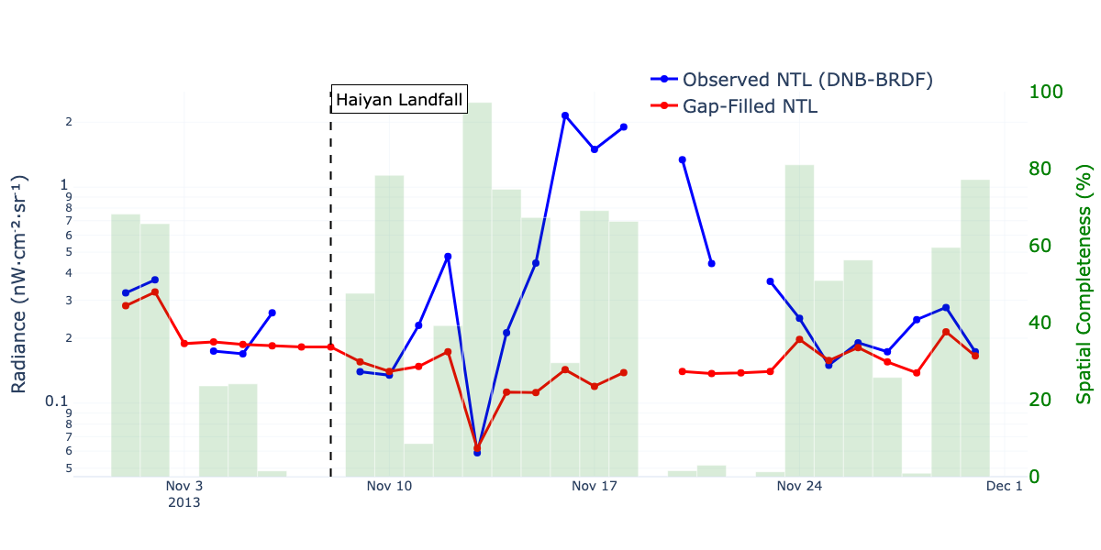Figure S1. Regional-scale mean DNB–BRDF (blue) and gap-filled radiance (red) for Samar–Leyte, with spatial completeness (%) shown as background bars. The dashed line marks Typhoon Haiyan landfall.
The gap-filled series, by contrast, produces a smoother and more continuous trajectory with reduced short-term variability. Periods of largest divergence between the two series align with low spatial completeness, indicating that interpolation effects are strongest when observational support is weakest. This demonstrates how gap-filling can preserve continuity at the expense of attenuating event-driven signal magnitude.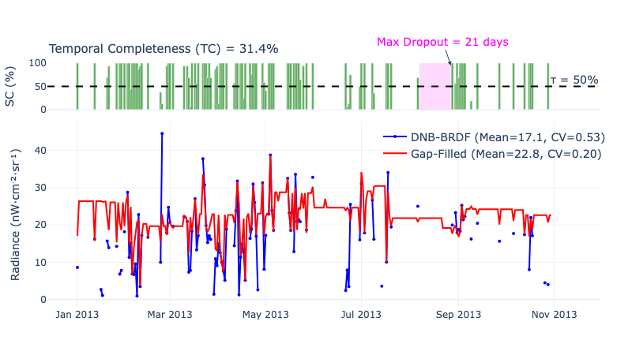
Figure S2. Pixel-scale observability diagnostics for a 1×1 extraction at Tacloban City centre. Top: temporal completeness relative to a spatial threshold, showing the maximum uninterrupted observation gap. Bottom: observed and gap-filled radiance time series with corresponding variability statistics.
Figure S2 provides a pixel-scale perspective using a 1×1 extraction at the Tacloban City centre. The upper panel shows temporal completeness relative to a spatial threshold, highlighting intermittent sampling and extended dropout periods. The lower panel compares observed and gap-filled radiance at the same location. The observed series exhibits high variability and episodic excursions, while the gap-filled series suppresses these fluctuations and increases apparent stability. Differences in mean radiance and coefficient of variation reflect the smoothing imposed by temporal propagation. Importantly, dropout windows coincide with periods where gap-filled values dominate the apparent signal, illustrating how interpolation can reshape both variance and temporal structure at fine spatial supports.
Together, these diagnostics establish two key properties of daily NTL in cloud-affected environments. First, observational availability is temporally fragmented across both regional and pixel scales, with dropout durations that can overlap short-lived disruption and early recovery periods. Second, gap filling estimates unavailable values from surrounding spatial and temporal information but does not provide additional direct observations. More recent reconstruction methods likewise seek to produce continuous daily NTL sequences by exploiting spatiotemporal dependencies (Hao et al., 2023; Tan and Zhu, 2023). These behaviours reinforce the observability metrics and admissibility thresholds evaluated in subsequent sections.
III. Long-Term Structure of Spatial Completeness
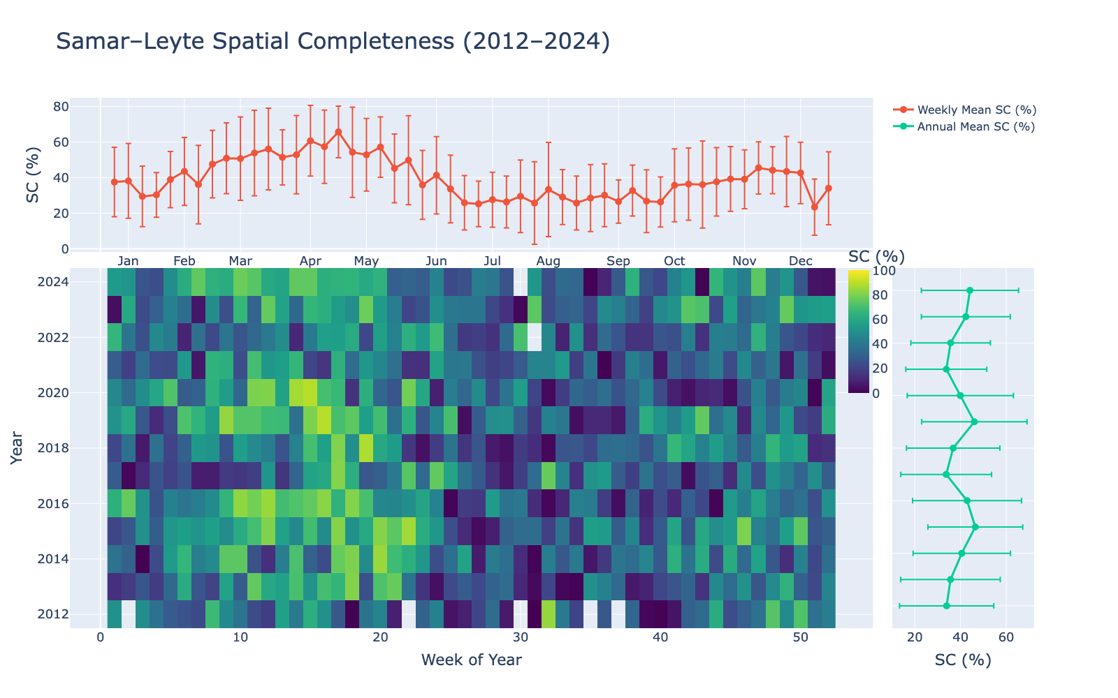Figure S3. Spatial completeness (%) for Samar–Leyte from 2012 to 2024. Top: weekly mean completeness with variability. Bottom-left: week-of-year heatmap showing seasonal and interannual structure. Bottom-right: annual mean completeness with variability ranges.
To contextualise the event-scale diagnostics, Figure S3 characterises the temporal structure of spatial completeness across the full 2012–2024 NASA Black Marble VNP46A2 record for Samar–Leyte. Weekly mean completeness exhibits pronounced seasonal variability, with higher values typically observed during boreal spring and lower completeness during monsoonal periods. This seasonality is consistent across years, indicating that observational availability is systematically modulated by regional cloud climatology rather than episodic disturbances alone.
The heatmap representation reveals substantial interannual variability superimposed on this seasonal cycle. Periods of persistently low completeness occur across multiple consecutive weeks, while high-completeness intervals are comparatively limited. These patterns confirm that extended dropout windows identified at the event and pixel scales are embedded within a broader regime of seasonally structured observation loss.
Annual summaries further demonstrate that mean completeness remains moderate across all years, with substantial variability around the mean. The persistence of this variability over more than a decade indicates that incomplete sampling is not an anomaly associated with specific events but a stable characteristic of NTL observations in humid tropical environments.
These results reinforce that observational intermittency arises from large-scale atmospheric dynamics and operates consistently across temporal scales. Consequently, any reliability framework must account for both short-term dropout behaviour and long-term completeness structure.
IV. Pre–Post Event Radiance Differences Across Spatial Supports
To quantify event-scale signal sensitivity, mean radiance differences (ΔNTL) before and after the 8 November 2013 landfall of Typhoon Haiyan were computed for urban centres, municipal centres, and non-settlement reference areas across three spatial supports (National Disaster Risk Reduction and Management Council, 2014). Supplementary Figure S4 summarises these pre–post contrasts.
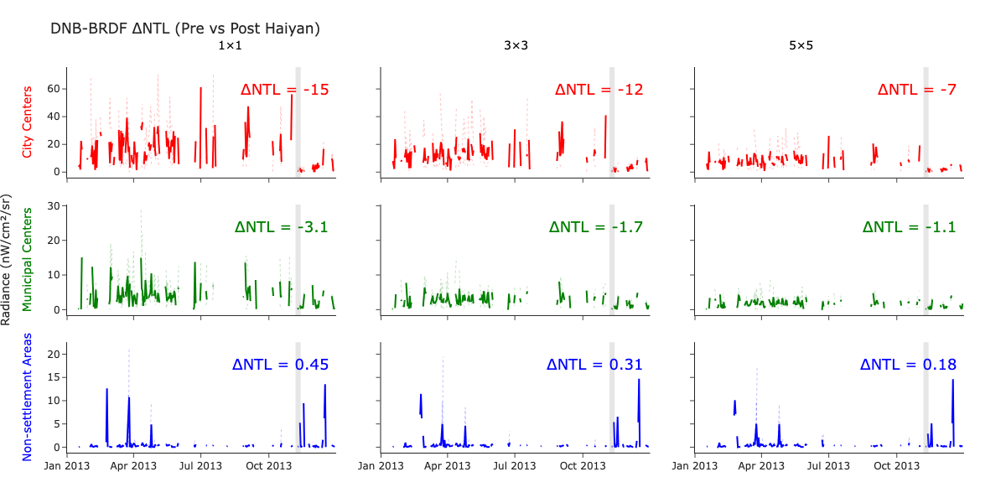
Figure S4. Pre–post Typhoon Haiyan ΔNTL values for representative POIs across 1×1, 3×3, and 5×5 supports.
ΔNTL was calculated as the mean post-event radiance (9 November 2013) minus the mean pre-event radiance (7 November 2013) using the reference landfall date of 8 November 2013, and retaining only dates satisfying SC ≥ τ.
Urban centres exhibit the largest negative ΔNTL values, indicating substantial radiance decline following the event. Municipal centres show moderate decreases, while non-settlement areas display near-zero or slightly positive changes, reflecting background noise and transient detections rather than infrastructure-driven signals.
Spatial support strongly influences magnitude estimates. Single-pixel (1×1) ΔNTL values show higher variance, whereas 5×5 supports produce more stable estimates but with slightly reduced effect magnitudes. This behaviour reflects a precision–stability trade-off inherent in spatial aggregation, where increased support reduces variability but smooths localized extremes.
These results reinforce the importance of spatial support selection in event-based NTL analysis and support the use of settlement-stratified aggregation to balance signal stability and sensitivity. Having established the influence of spatial support, we next examine the effect of temporal interpolation through gap-filled radiance.
V. Kernel-Scale Comparison of DNB-BRDF and Gap-Filled Radiance
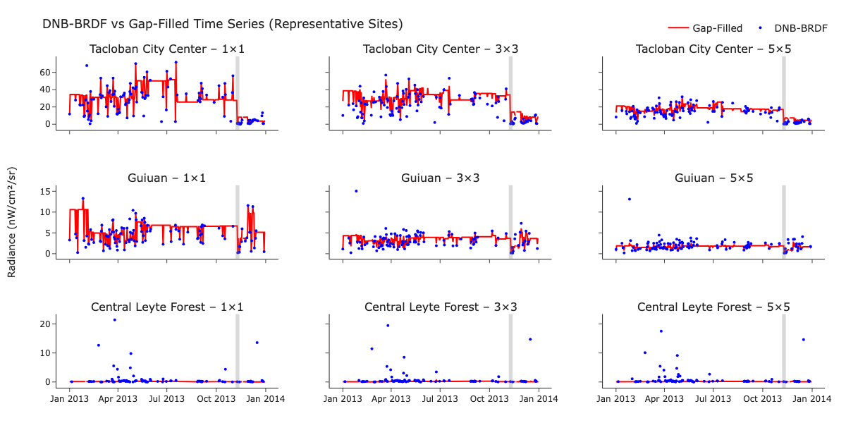Figure S5. DNB-BRDF (blue) and gap-filled (red) radiance time series for representative POIs in 2013 across 1×1, 3×3, and 5×5 supports. The vertical grey bar indicates Typhoon Haiyan landfall.
To examine the effect of temporal interpolation at fine spatial scales, DNB-BRDF and gap-filled radiance series were compared across representative POIs and spatial supports (1×1, 3×3, and 5×5 pixels). Supplementary Figure S5 presents time series for an urban centre (Tacloban City), a municipal centre (Guiuan), and a non-settlement reference (Central Leyte Forest) during 2013.
Across all sites, the gap-filled series exhibits reduced short-term variability relative to DNB-BRDF, with the strongest smoothing observed at the 1×1 support. In urban locations, interpolation dampens the abrupt radiance decline immediately following Typhoon Haiyan, while in non-settlement areas it suppresses episodic spikes present in the raw DNB-BRDF signal. These effects indicate that gap-filling modifies both the magnitude and temporal sharpness of observed radiance dynamics.
Spatial aggregation (3×3 and 5×5) reduces noise in both series; however, structural differences between DNB-BRDF and gap-filled radiance persist across all supports. While aggregation improves stability, it does not reconcile discrepancies introduced by temporal imputation.
These results show that gap-filling increases apparent temporal continuity but can attenuate abrupt change signals that are critical for outage detection, particularly at finer spatial scales.
VI. Full POI-Level Observability Metrics
Table S2 reports spatial completeness (SC), temporal completeness (TC), and maximum consecutive dropout duration for all ten POIs across three spatial supports (1×1, 3×3, and 5×5 pixels), derived from quality-screened DNB-BRDF observations.
Table S2. Spatial completeness (%), temporal completeness (%), and maximum consecutive dropout duration (days) for all POIs across 1×1, 3×3, and 5×5 supports.
 | Spatial Completeness (%) |  |  | Temporal Completeness (%) |  |  | Maximum Dropout Duration (days)
 | 1×1 | 3×3 | 5×5 | 1×1 | 3×3 | 5×5 | 1×1 | 3×3 | 5×5
City Centres (AVG) | 31.1 | 28.9 | 26.5 | 31.1 | 30.3 | 28.9 | 14 | 14 | 14
Tacloban City Centre | 32.6 | 30.8 | 28.7 | 32.6 | 31.8 | 29.9 | 11 | 11 | 13
Ormoc City Centre | 32.3 | 29.4 | 27.0 | 32.3 | 32.1 | 31.0 | 15 | 15 | 15
Baybay City Centre | 28.5 | 26.5 | 23.8 | 28.5 | 27.1 | 26.0 | 15 | 15 | 15
Municipal Centres (AVG) | 33.5 | 31.9 | 30.2 | 33.5 | 33.1 | 32.7 | 13 | 13 | 13
Palo | 34.8 | 33.7 | 32.8 | 34.8 | 34.0 | 34.0 | 13 | 13 | 13
Alang Alang | 35.3 | 33.6 | 32.7 | 35.3 | 35.6 | 34.5 | 11 | 11 | 11
Guiuan | 30.4 | 28.3 | 24.9 | 30.4 | 29.6 | 29.6 | 15 | 15 | 15
Non-settlement Areas (AVG) | 26.7 | 24.9 | 24.2 | 26.7 | 26.4 | 26.2 | 27 | 26 | 27
Samar Forest Reserve | 34.5 | 33.6 | 33.0 | 34.5 | 35.3 | 34.5 | 12 | 12 | 15
Mt. Nacolod Upland | 35.6 | 32.8 | 32.0 | 35.6 | 35.1 | 35.3 | 16 | 13 | 13
Central Leyte Forest | 23.6 | 21.8 | 21.1 | 23.6 | 23.3 | 23.3 | 18 | 18 | 18
Southern Leyte Gulf | 13.2 | 11.4 | 10.9 | 13.2 | 11.8 | 11.5 | 61 | 62 | 62
Across POIs, completeness metrics show relatively narrow ranges, but maximum dropout duration varies more substantially. Locations with similar SC and TC values may exhibit markedly different maximum gap lengths, indicating that completeness alone does not fully capture temporal continuity. Southern Leyte Gulf exhibits both the lowest completeness and the longest dropout duration among the reference sites.
Increasing spatial support produces only small changes in completeness, which generally declines slightly from the 1×1 to 5×5 grouped summaries, while maximum dropout duration remains largely unchanged. This indicates that increasing kernel support modifies the spatial averaging of retained observations but does not increase overall completeness or resolve extended observation gaps.
Within settlement categories, urban POIs tend to exhibit slightly higher consistency across supports, whereas forested and upland locations show greater divergence between supports. This reflects differences in spatial heterogeneity, where mixed land cover within aggregation windows introduces additional variability in completeness and stability metrics.
These detailed POI-level results provide additional context for interpreting completeness thresholds by highlighting how similar summary statistics can correspond to different temporal structures of observation gaps.
VII. Settlement-Scale Observability Summary
Table S3. Settlement-scale observability metrics including spatial completeness, temporal completeness under varying thresholds, dropout duration, pixel share, and radiance variability (CV) across GHSL SMOD classes.
Settlement Class | Pixel Share  (%) | SC (%) | TC (%) |  |  | Maximum Dropout  Duration  (Days) | Temporal CV | Spatial CV
Settlement Class | Pixel Share  (%) | SC (%) | ≥ 25% | ≥ 50% | ≥ 75% | Maximum Dropout  Duration  (Days) | Temporal CV | Spatial CV
Urban Centre (30) | 0.55 | 36.6 | 47.4 | 35.9 | 24.7 | 40 | 1.56 | 1.16
Urban Cluster | 14.39 | 38.6 | 50.7 | 37.9 | 24.2 | 45 | 1.23 | 1.42
Dense Urban Cluster (23) | 11.14 | 37.9 | 50.6 | 37.9 | 23.9 | 45 | 2.03 | 1.49
Semi-dense Urban Cluster (22) | 1.57 | 39.1 | 51.1 | 38.4 | 24.6 | 33 | 0.81 | 1.17
Suburban/Peri-urban Cluster (21) | 1.68 | 38.9 | 50.6 | 37.3 | 24.0 | 33 | 0.85 | 1.62
Non-urban Cells | 84.15 | 38.2 | 52.5 | 39.0 | 23.5 | 45 | 1.36 | 1.28
Rural Cluster (13) | 63.78 | 39.5 | 53.4 | 39.8 | 25.0 | 33 | 2.18 | 1.43
Low-density Rural (12) | 16.39 | 37.7 | 51.8 | 38.6 | 22.6 | 45 | 1.07 | 1.33
Very Low-density Rural (11) | 3.98 | 37.6 | 52.4 | 38.7 | 22.8 | 33 | 0.83 | 1.08
Water (10) | 0.99 | 66.6 | 57.8 | 47.7 | 38.8 | 26 | 7.49 | 1.41
Table S3 reports settlement-scale observability metrics across the Global Human Settlement Layer Degree of Urbanisation Settlement Model classes (GHSL SMOD; Schiavina et al., 2023). This includes spatial completeness (SC), temporal completeness under admissibility thresholds (≥25%, ≥50%, ≥75%), maximum dropout duration, pixel share, and radiance variability (temporal and spatial CV).
While spatial completeness varies only slightly across settlement types, the response to increasing admissibility thresholds differs between classes. Urban and peri-urban categories show relatively uniform declines in temporal completeness as thresholds increase, whereas rural subclasses exhibit more variable responses, reflecting differences in spatial fragmentation and baseline signal strength.
Radiance variability further differentiates subclasses within broader settlement groups. Dense urban clusters exhibit higher temporal CV relative to aggregated urban clusters, indicating greater intra-class heterogeneity despite higher overall brightness. In contrast, very low-density rural classes show lower temporal variability but also reduced signal magnitude, limiting interpretability despite apparent stability.
Pixel share strongly conditions the aggregate representation of these metrics. Non-urban classes dominate the spatial domain, meaning that unstratified analyses would disproportionately reflect lower-intensity, higher-noise environments. This reinforces the role of settlement stratification in isolating infrastructure-relevant signals from background variability.
Taken together, the settlement-scale metrics highlight that observability is not only a function of completeness, but also of how variability, spatial composition, and threshold sensitivity interact across settlement regimes.
VIII. Example GHSL Cumulative Thematic Masks Used for Aggregation
Figure S6 illustrates representative GHSL SMOD cumulative thematic masks used for aggregation of NTL radiance. These masks define spatial subsets corresponding to distinct settlement regimes, ranging from dense urban cores to rural and non-urban classes.
The masks differ not only in spatial extent but also in morphological structure. Urban masks are spatially compact and concentrated around high-intensity emission centres, whereas rural and non-urban masks are more spatially dispersed and fragmented. This structural contrast influences both the density of radiance signals and the distribution of valid observations within each class.

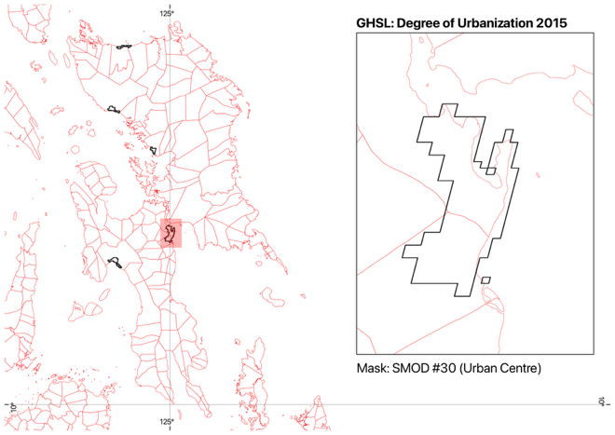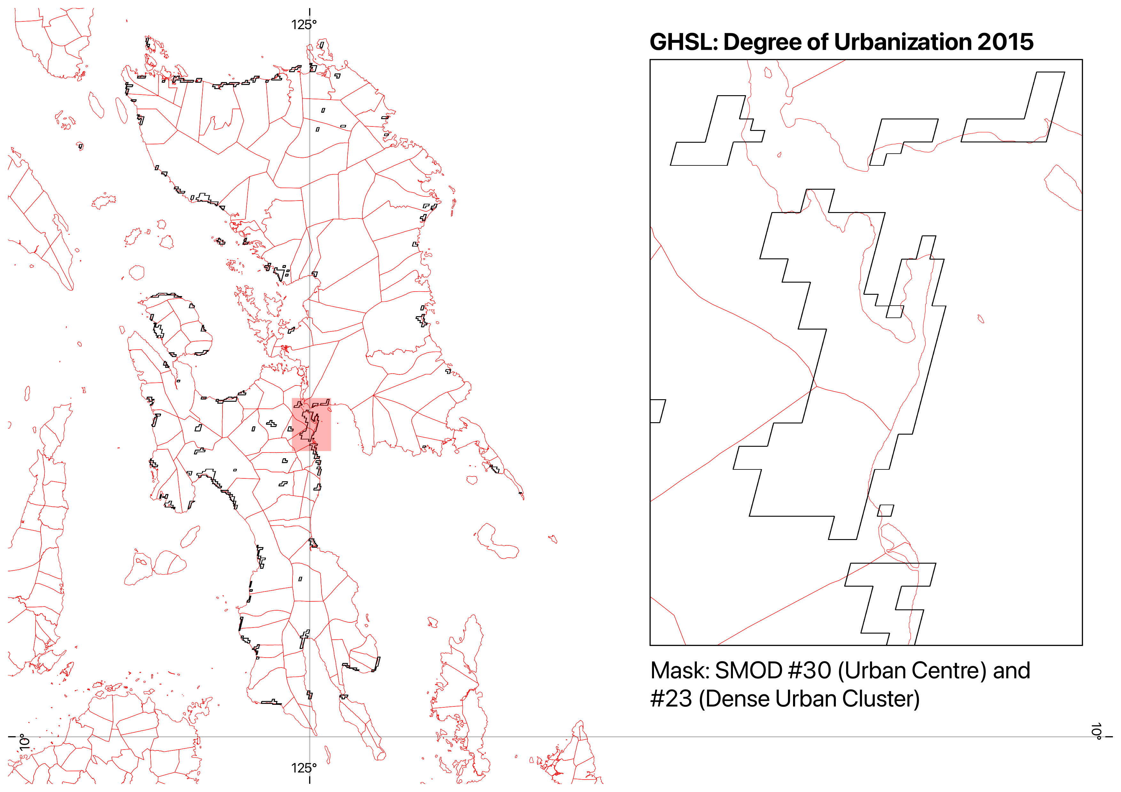
Figure S6. Representative cumulative thematic masks derived from GHSL SMOD classes, showing G1 (Urban Core, code 30) and G2 (Dense Urban, codes 23–30).
Differences in mask composition also affect the degree of spatial mixing during aggregation. Urban masks primarily capture contiguous built-up areas, while broader masks incorporate heterogeneous land covers, including transitional and low-emission zones. These distinctions provide the basis for evaluating how settlement structure conditions both signal stability and alignment with external datasets.
IX. Effect of Spatial Completeness Threshold on Event Signal Structure
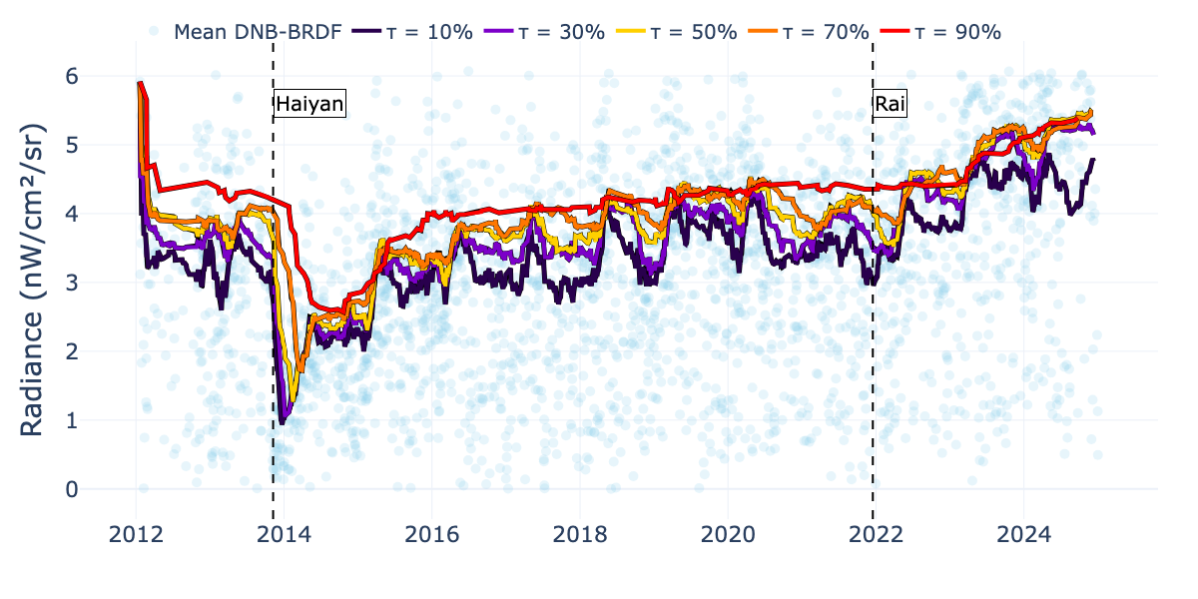
Figure S7. NTL time series under varying spatial completeness thresholds (τ), showing changes in short-term variability and temporal continuity during the Typhoon Haiyan period.
Figure S7 illustrates the effect of varying spatial completeness thresholds (τ) on the structure of NTL time series during the Typhoon Haiyan period. Time series are shown for multiple admissibility levels, highlighting how threshold selection alters the representation of event-driven radiance dynamics.
Lower thresholds retain a larger number of observations but introduce increased variability and residual noise, resulting in less distinct event signatures. As τ increases, short-term fluctuations are reduced, but the time series becomes progressively fragmented as stricter thresholds exclude a larger proportion of dates. However, this increased clarity is accompanied by fragmentation of the time series, as stricter thresholds exclude a substantial fraction of days.
The effect of thresholding extends beyond noise reduction. Changes in τ alter the apparent depth, duration, and temporal continuity of the radiance decline associated with the event. At lower thresholds, the disruption signal may appear attenuated or temporally diffuse, while at higher thresholds, the signal becomes sharper but discontinuous due to missing segments. This demonstrates that threshold selection directly influences the interpretability of event-scale dynamics.
Thresholding produces a continuous trade-off rather than a universally optimal intermediate setting. Lower thresholds retain more dates but include observations with weaker spatial support, whereas stricter thresholds reduce temporal coverage and increase fragmentation. The preferred threshold therefore depends on the settlement mask, validation target, and relative weighting assigned to association, error, and temporal coverage. The threshold-dependent patterns in Figure S7 occur across settlement classes, although their magnitude and stability vary with baseline radiance and spatial heterogeneity.
X. Effect of Spatial Completeness Threshold on NTL–Load Signal Structure
This section examines how spatial completeness thresholds (τ) alter settlement-stratified VNP46A2 radiance and its correspondence with NGCP sub-grid electricity load (Román et al., 2018; National Grid Corporation of the Philippines, n.d.). Figure S8 presents unnormalised DNB–BRDF radiance across GHSL classes under representative thresholds (τ = 10%, 50%, and 90%), alongside NGCP load.
At τ = 10%, temporal coverage is highest and the urban-focused series retain strong correspondence with NGCP load, although greater short-term variability remains visible. At τ = 50%, the broad temporal trajectory is preserved but fewer dates contribute to the series. At τ = 90%, retained observations are sparse and the time series becomes highly fragmented, limiting representation of continuous system dynamics. The comparison demonstrates that increasing τ does not uniformly improve alignment; it progressively exchanges temporal coverage for stronger spatial support.
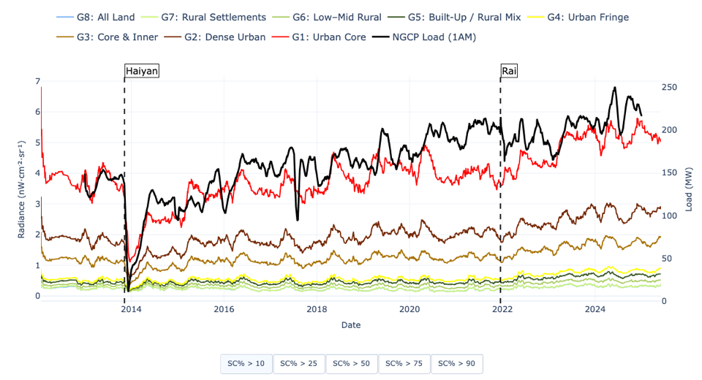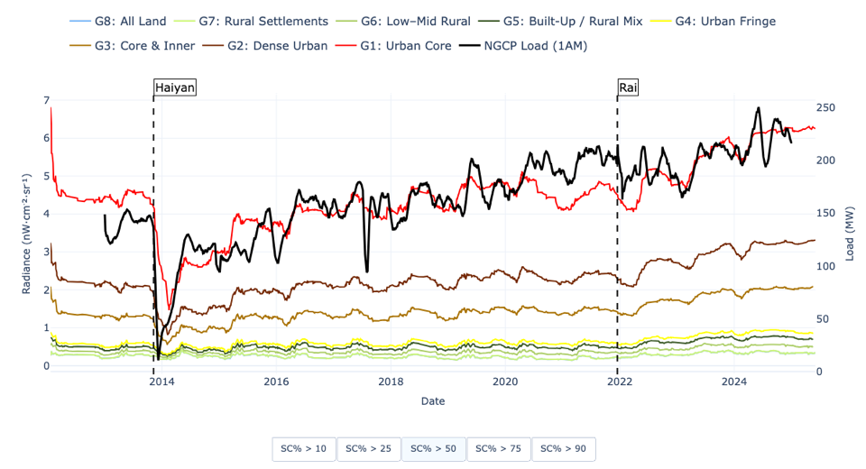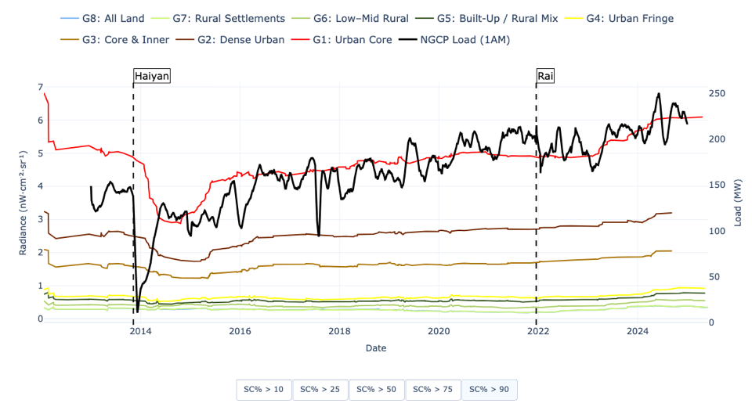
Figure S8. GHSL-stratified DNB–BRDF radiance and NGCP load under varying spatial completeness thresholds: (a) τ = 10%, (b) τ = 50%, (c) τ = 90%. Dashed vertical lines indicate major typhoon events (Haiyan and Rai).
Across all thresholds, the effect is most pronounced in urban classes, where baseline radiance is highest and alignment with load is strongest. Rural-dominant classes remain comparatively stable but exhibit weaker correspondence with load across all τ values. These results demonstrate that threshold selection directly reshapes the amplitude, continuity, and timing of NTL signals, rather than simply filtering noise. The main analysis therefore evaluates this trade-off using the composite score rather than prespecifying an intermediate threshold as universally preferable.
XI. Top Five Reliability-Qualified Alignment Configurations for Each Visayas Sub-Grid
Table S10. Five highest-scoring reliability-qualified NTL–load alignment configurations within each Visayas sub-grid. Composite scores combine within-sub-grid normalised Pearson correlation, inverted RMSE, and retained temporal coverage using weights of 0.6, 0.1, and 0.3, respectively. Scores rank configurations within each sub-grid and should not be compared directly between sub-grids.
Sub-grid | Rank | Thematic Mask | GHSL Range | τ (%) | Composite Score | r | RMSE | Temporal Coverage (%)
Samar–Leyte | 1 | G2: Dense Urban | 23-30 | 10 | 0.937 | 0.84 | 0.57 | 49.81
Samar–Leyte | 2 | G1: Urban Core | 30 | 10 | 0.934 | 0.85 | 0.54 | 46.59
Samar–Leyte | 3 | G3: Core & Inner | 22-30 | 10 | 0.922 | 0.82 | 0.61 | 50.25
Samar–Leyte | 4 | G1: Urban Core | 30 | 20 | 0.907 | 0.86 | 0.53 | 40.82
Samar–Leyte | 5 | G2: Dense Urban | 23-30 | 20 | 0.907 | 0.85 | 0.55 | 42.86
Bohol | 1 | G1: Urban Core | 30 | 20 | 0.880 | 0.86 | 0.54 | 28.71
Bohol | 2 | G1: Urban Core | 30 | 10 | 0.875 | 0.85 | 0.56 | 31.32
Bohol | 3 | G1: Urban Core | 30 | 30 | 0.860 | 0.86 | 0.54 | 26.62
Bohol | 4 | G2: Dense Urban | 23-30 | 20 | 0.859 | 0.83 | 0.57 | 32.50
Bohol | 5 | G3: Core & Inner | 22-30 | 30 | 0.859 | 0.84 | 0.56 | 30.45
Cebu | 1 | G1: Urban Core | 30 | 60 | 0.735 | 0.78 | 0.67 | 21.38
Cebu | 2 | G1: Urban Core | 30 | 50 | 0.728 | 0.77 | 0.68 | 23.57
Cebu | 3 | G1: Urban Core | 30 | 30 | 0.717 | 0.75 | 0.71 | 27.53
Cebu | 4 | G2: Dense Urban | 23-30 | 70 | 0.712 | 0.78 | 0.66 | 15.82
Cebu | 5 | G1: Urban Core | 30 | 40 | 0.708 | 0.75 | 0.70 | 25.51
Negros | 1 | G1: Urban Core | 30 | 10 | 0.897 | 0.78 | 0.66 | 38.69
Negros | 2 | G2: Dense Urban | 23-30 | 10 | 0.881 | 0.72 | 0.75 | 42.97
Negros | 3 | G1: Urban Core | 30 | 20 | 0.867 | 0.79 | 0.65 | 33.64
Negros | 4 | G3: Core & Inner | 22-30 | 10 | 0.862 | 0.68 | 0.81 | 43.83
Negros | 5 | G2: Dense Urban | 23-30 | 20 | 0.857 | 0.75 | 0.71 | 36.14
Panay | 1 | G2: Dense Urban | 23-30 | 10 | 0.889 | 0.80 | 0.64 | 43.89
Panay | 2 | G2: Dense Urban | 23-30 | 20 | 0.877 | 0.84 | 0.56 | 37.30
Panay | 3 | G3: Core & Inner | 22-30 | 10 | 0.873 | 0.77 | 0.68 | 44.48
Panay | 4 | G3: Core & Inner | 22-30 | 20 | 0.865 | 0.82 | 0.61 | 38.33
Panay | 5 | G2: Dense Urban | 23-30 | 30 | 0.853 | 0.85 | 0.54 | 32.50
The expanded rankings show that all top-five configurations remain restricted to the three most urban-focused cumulative thematic masks (G1–G3). Within each sub-grid, several neighbouring mask–threshold configurations yield closely comparable scores, although the preferred threshold range differs regionally. Samar–Leyte, Negros, and Panay favour low thresholds, while Bohol favours low-to-moderate thresholds and Cebu favours a broader set of moderate-to-strict G1 configurations. Settlement-mask selection is therefore more stable across sub-grids than the precise completeness threshold.
XII. Supplementary References
Hao, X., Liu, J., Heiskanen, J., Maeda, E. E., Gao, S., and Li, X. (2023). A robust gap-filling method for predicting missing observations in daily Black Marble nighttime light data. GIScience & Remote Sensing, 60(1), 2282238. https://doi.org/10.1080/15481603.2023.2282238
National Disaster Risk Reduction and Management Council. (2014). Final report re effects of Typhoon “Yolanda” (Haiyan). National Disaster Risk Reduction and Management Council, Quezon City, Philippines. https://www.greenpeace.org/static/planet4-philippines-stateless/2019/05/8006f16f-8006f16f-final_report_re_effects_of_typhoon_yolanda_haiyan_06-09nov2013.pdf
National Grid Corporation of the Philippines. (n.d.). Hourly demand. NGCP Operations Data. Retrieved 16 June 2026, from https://www.ngcp.ph/operations
Román, M. O., Wang, Z., Sun, Q., Kalb, V. L., Miller, S. D., Molthan, A. L., Schultz, L. A., Bell, J., Stokes, E. C., Pandey, B., Seto, K. C., Hall, D. K., Oda, T., Wolfe, R. E., Lin, G., Golpayegani, N., Devadiga, S., Davidson, C., Sarkar, S., Praderas, C., Schmaltz, J., Boller, R., Stevens, J., Ramos González, O. M., Padilla, E., Alonso, J., Detrés, Y., Armstrong, R., Miranda, I., Conte, Y., Marrero, N., MacManus, K., Esch, T., and Masuoka, E. J. (2018). NASA’s Black Marble nighttime lights product suite. Remote Sensing of Environment, 210, 113–143. https://doi.org/10.1016/J.RSE.2018.03.017
Schiavina, M., Melchiorri, M., and Pesaresi, M. (2023). GHS-SMOD R2023A: GHS settlement layers, application of the Degree of Urbanisation methodology (stage I) to GHS-POP R2023A and GHS-BUILT-S R2023A, multitemporal (1975–2030) [Dataset]. European Commission, Joint Research Centre. https://doi.org/10.2905/A0DF7A6F-49DE-46EA-9BDE-563437A6E2BA
Tan, X., and Zhu, X. (2023). CRYSTAL: A novel and effective method to remove clouds in daily nighttime light images by synergizing spatiotemporal information. Remote Sensing of Environment, 295, 113658. https://doi.org/10.1016/j.rse.2023.113658

